# Competency Test

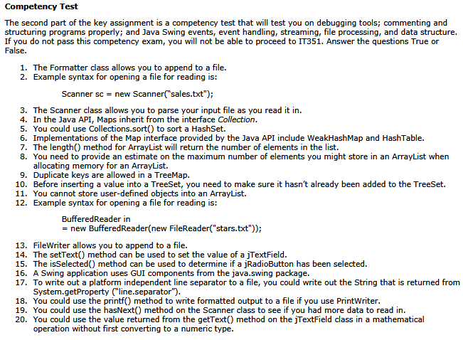

ANSWERS:

|  |  |  |  |  |  |  |  |  |  |  |  |  |  |  |  |  |  |  |  |
| --- | --- | --- | --- | --- | --- | --- | --- | --- | --- | --- | --- | --- | --- | --- | --- | --- | --- | --- | --- |
| .1 | .2 | .3 | .4 | .5 | .6 | .7 | .8 | .9 | .10 | .11 | .12 | .13 | .14 | .15 | .16 | .17 | .18 | .19 | .20 |
| T | T | T | F | F | T | F | F | F | F | F | T | T | T | T | F | F | T | T | F |